**Phys 11A - Eiteneer**

**Friction Project**

**Online version**

**Names: ______________________________________________________________________________**

**Purpose**

To practice with drawing working with forces, in particular frictional forces, as well as work done by such forces.

**Problem statement**

**Design, carry out, and analyze an experiment that allows you to determine a coefficient of kinetic friction between a solid object and a solid surface (no rolling), and the amount of work done by the force of friction as an object is moving along a surface.**

**Format**

This project can be done either individually or in groups (no more than 3 people per group). You can sign up for your groups on Canvas. You will spend one week designing your project, and (upon approval of your design) one week collecting data and coming up with a project report.

This is a really open-ended project. Basically, I want you to practice with frictional forces and work done by such forces (on one hand), and to try your hand in designing an experiment (on another).

You will be graded on your design (creativity, usefulness), on a visual representation of the experiment (you can film a video, create a powerpoint, maybe even write a computer game?), as well as on the quality of your data (completeness, overall quality), your analysis, and your conclusion.

**Deliverables**

(20% of project grade) Project/design outline due Monday, October 19th, at 11:59pm

(30% of project grade) Visual due Monday, October 26th, at 11:59pm

(50% of project grade) Project report due Monday, October 26th, at 11:59pm

The Outline and the Report should be typed (size 11 or 12 font), single spaced. You may write out equations/calculations by hand. **Absolutely no late work will be accepted, for ANY reason.**

*Project report should include the following parts:*

**Title page** – It has to include names of group members (first name/nickname and last initial is ok), the title of the experiment – be creative with the title, don’t just call it “Friction Project”

**Objective statement / purpose of the experiment -** In one or two sentences, describe the purpose of this experiment and how it is relevant to the current topic we are studying in lecture. As in, describe what concepts/constructs are taking part in the experiments.

**Theory/background and Experimental procedure –** Briefly describe the procedure, including what materials/tools/instruments you used. Do not just copy all the steps out of the lab handout. Instead, state what you measured and how (for example, you can say “we measured the distance between two objects in meters using a measuring tape”). Also include a brief description of analysis you did and/or graphs you produced, as applicable (for example, “from the masses and the distance we calculated the strength of the gravitational force” or “we graphed pressure vs. depth of liquid to confirm that the relationship between the two is linear”). This part should be no more than one or paragraph, but it should be complete, coherent and logical. Use complete sentences!

**Results / data and analysis -** This part is where you include all the data tables, graphs, etc. collected and/or created while working on the project. You also need to include all the necessary calculations performed during and after data collection. Make sure all the tables have headings and units, and all the graphs have titles and axes labeled (including units). If you are including a best-fit line/curve, make sure that the equation is displayed on the graph together with the R2 value. *Note:* All the measured values should include uncertainties. The best ways to include uncertainties is in the format 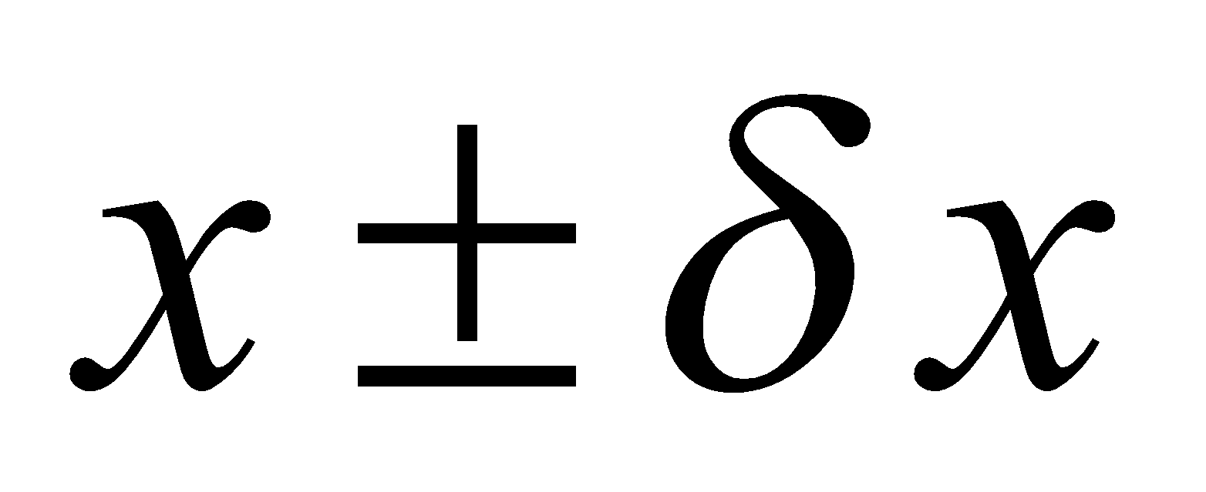 (if there are only few measurements), or in a table with a δx column(s) (if there are many measurements).

**Error analysis -** If the value you are measuring has an “actual” or an “accepted” value (for example, acceleration due to gravity, g = 9.8 m/s2), you can find percent error between the measured and the accepted value, otherwise, if performing two different measurements and/or calculations, you can find percent difference between them. Show your calculation (you may do so by hand), and make sure that the final % difference or % error is clearly displayed. We are always hoping for less than 5% error, but experiments don’t always work as well as we would like. In two or three sentences, comment on the possible source of errors, trying to be scientific about it. Just saying “human error” is not good enough; if one of the group members made a mistake in measurements, state so (no need for the name of that group member). Below is the list of common sources of error. When writing up your error analysis, carefully consider all the possible sources of error and describe each one that applies to a particular situation or measurement in a sentence.

**Conclusion -** Conclusion should start with a few sentences that echo (but not copy/paste) your objective, theory, and procedure. After that, about a paragraph or two summarizing your analysis, such as “we concluded that the relationship between x and y should have been linear. However, because of systematic errors mentioned earlier, the graph yielded a parabolic graph.” ALWAYS include the final values that you calculated, in the  format (with units), as well as percent error or percent difference (if applicable) or standard deviation. In principle, a person familiar with physics concepts and the ideas of properly conducting a lab experiment, should be able to read ONLY your conclusion and be able to tell how the experiment was conducted, what was the purpose and the outcome of the experiment, what was measured and how, and all the relevant values that were measured and calculated. Conclusion should be anywhere between half a page and one page (no longer), single spaced. I should be able to just turn to the last page of your report, read your conclusion, and know what the experiment was about, how it was conducted, and what the most important results were. If I read your conclusion, and cannot mentally recreate your experiment, the highest score you will get for the report will be 2 out of 5. *Note:* do not put any tables, graphs, equations or calculations into the conclusion. There are other places in the report where all these should go.

**Bibliography/sources** – no less than 5 sources (this may include your textbook/manual, and any website you use. You may use any format, but be consistent.